### Group viewer

The *Group Viewer* is the place within FT NavVision that holds the necessary information about all connected I/O. In this window, you can find a descriptive line for all the sensors with their connections and dependencies (see Figure 1‑17).

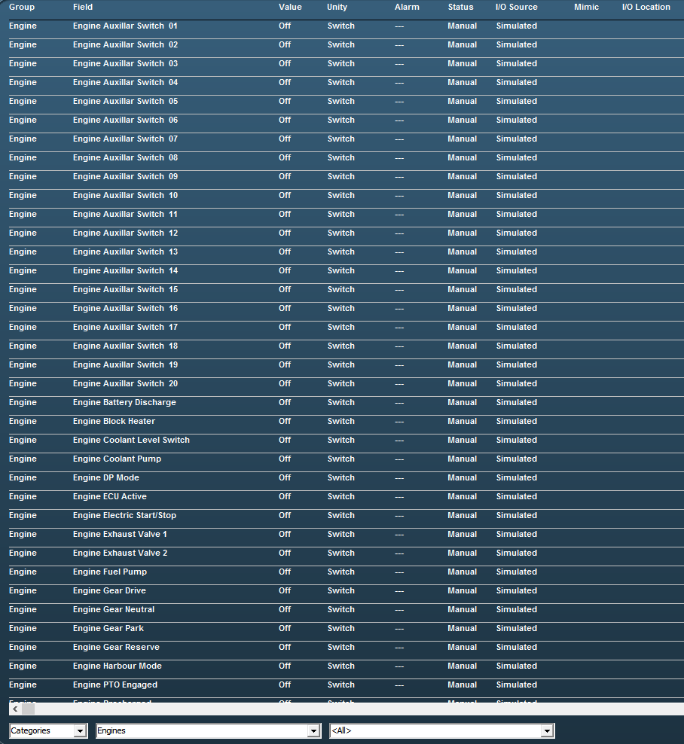

Figure 1‑17: Group viewer

There are various columns that each list a specific piece of metadata of an I/O point in clear language or digits and colors.

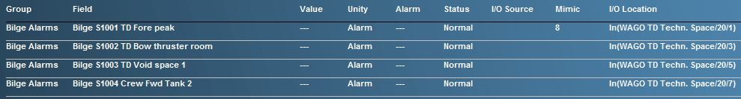

Figure 1‑18: Group Viewer columns

|  |  |
| --- | --- |
| **Column** | **Explanation** |
| Group | The alarm group the I/O point belongs to |
| Field | The item name of the I/O point (FT NavVision ID-tag) |
| Value | Actual value of the I/O point |
| Unity | The Unity of the I/O point |
| Alarm | Shows if the I/O point is in alarm and the value of the alarm |
| Status | Status of the I/O point |
| I/O Source | The source (interface) the I/O point comes from |
| Mimic | The mimic(s) the I/O point value is present |
| I/O Location | The location where you can find the I/O point physically |

Table 4: Group Viewer columns

#### The search bar

Using the search bar, you can reduce the amount of searchable data to a specified group. This way it is easier to pinpoint the faulty I/O point you are looking for (see Figure 1‑19).



Figure 1‑19: Search bar

In the first drop-down menu, you can choose between *Categories* and *Alarm Groups* in which you change between the standard arrangement of categories as set in FT NavVision or the division in alarm groups.

When choosing for *Alarm Groups,* you have the choice to narrow the selection down even further to the specific alarm group that you are looking for (see Figure 1‑20).

When you choose for the *Categories*, you can narrow it down to the group and even subgroup for that particular I/O point (see Figure 1‑21 and Figure 1‑22).

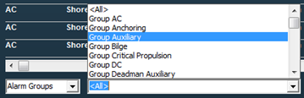

Figure 1‑20: Alarm groups

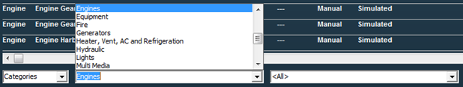

Figure 1‑21: Categories group

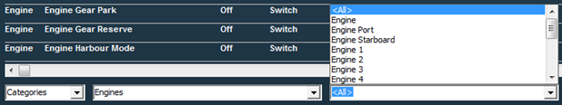

Figure 1‑22: Categories subgroup

If there is an I/O point currently in alarm status, it will give information on the fact that it is in alarm (red) and what its status is (see Figure 1‑23). Also the mimic it is presented on and the I/O location can be read from the group viewer (see Figure 1‑24).



Figure 1‑23: Group viewer in alarm



Figure 1‑24: Group viewer mimic and I/O location